**Linux Kernel (Piece of Software)**

It is a core component in Linux operating system, Used as a bridge between computer hardware & Software application which are running on Operating System.

The Kernel is responsible for managing system resources, like as the CPU, Memory & device driver, which is responsible for running Software Application, it ensuring that these resources are used efficiently & securely.

**Key Functions of the Linux Kernel:**

1. **Process Management**: Handles the creation, scheduling, and termination of processes.
2. **Memory Management**: Allocates and deallocates memory to processes and manages virtual memory.
3. **Device Drivers:** Provides an interface for the Operating System to communicate with hardware device
4. **File System Management:** Control access to the files, directories & manage file storage
5. **Networking:** Implements protocols to enable data exchange between devices over network
6. **Security & Permission:** Enforces user & process permissions to ensure system security

The **Linux kernel** being monolithic means that it includes most of the system's core functionality in a single large binary that runs in a **single memory space** (called "kernel space"). This design allows the kernel to access hardware resources and execute tasks efficiently without the overhead of inter-process communication that is common in other architectures, like micro-kernels.

**Monolithic Kernel Explained**

1. **Single Memory Space:**
   * The kernel operates in a protected memory region called **kernel space** (separate from user space where applications run).
   * All core functionalities like process management, memory management, and device drivers reside in this kernel space.
   * Since these functionalities share the same memory space, the kernel can perform operations faster due to direct access to resources.
2. **In-Kernel Execution:**
   * Unlike a microkernel (where core functionalities are split into separate processes running in user space), a monolithic kernel bundles all these functionalities into one unit.
   * This avoids the need for complex message-passing mechanisms between components, enhancing performance.
3. **Examples of Core Functionalities:**
   * **File system management** (e.g., EXT4, XFS)
   * **Process scheduling** and resource allocation
   * **Networking stacks** for communication
   * **Device drivers** for hardware interaction

**Dynamic Loading of Modules**

A key feature of the Linux kernel is its ability to **dynamically load and unload modules**, which are pieces of code that extend the kernel's functionality at runtime. This means:

1. **No Reboot Needed:**
   * New hardware or software features can be added without rebooting the system. For example, if you plug in a new USB device, the kernel can load the required driver automatically.
2. **Modular Design:**
   * Modules act as "plug-ins" for the kernel. They include functionality like device drivers, file systems, or additional network protocols.
   * They can be loaded using tools like insmod or modprobe and removed using rmmod.
3. **Advantages of Dynamic Modules:**
   * **Efficiency:** Modules are loaded only when needed, reducing the kernel's memory footprint.
   * **Flexibility:** Developers can write and test new modules without modifying the core kernel.

**Open Source and Community Development**

The Linux kernel is **open-source**, meaning its source code is freely available under the **GPL (GNU General Public License)**. This has several implications:

1. **Global Contribution:**
   * Thousands of developers and organizations contribute to the kernel, ensuring rapid development, bug fixes, and security updates.
2. **Customizability:**
   * Developers can modify the kernel to suit specific needs, such as creating lightweight versions for embedded systems or tailored distributions for servers.
3. **Frequent Updates:**
   * The kernel is regularly updated with new features, better hardware support, and improved performance.
   * These updates are managed by a structured hierarchy, with **Linus Torvalds** (the creator of Linux) overseeing the core project.

Question: - Is Kernel having Separate memory space?

Answer: - **Memory Separation: Kernel vs. Applications**

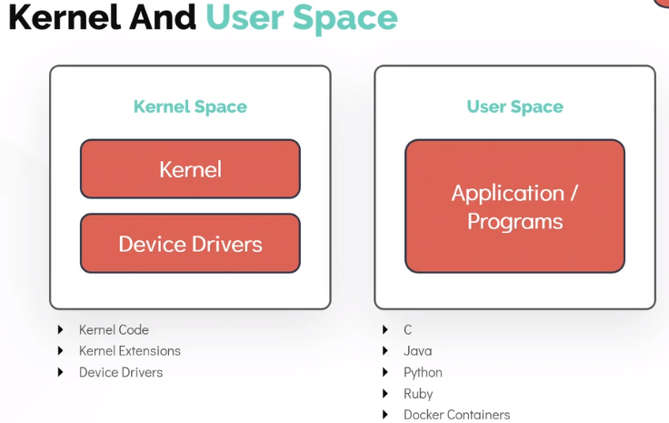

* **Kernel Space**:

The kernel operates in a reserved part of the system's memory called **kernel space**.

Only the kernel and its modules (e.g., drivers, network stacks) have access to this memory.

This space is protected, meaning user applications cannot directly access or modify kernel memory. This protects the system from accidental or malicious interference by user-level processes.

* **User Space**:

Applications run in **user space**, which is a separate and isolated memory region.

Each application gets its own virtual memory space, which prevents one application from interfering with another or with the kernel.

**Why is Dedicated Memory Important for the Kernel?**

1. **Stability**:

* If applications had direct access to kernel memory, a bug or malicious code in an application could crash the entire system. By isolating kernel memory, the system remains stable even if an application misbehaves.

1. **Security**:

* Kernel memory often contains sensitive information (e.g., encryption keys, device configurations). Protecting this memory ensures that unauthorized applications cannot access it.

1. **Performance**:

* By reserving a dedicated memory space, the kernel can operate efficiently without competing with applications for memory resources.

1. **Efficiency in Context Switching**:

* When switching between user and kernel modes, the CPU can quickly access the kernel memory without needing to reload memory mappings for user processes.

**Summary**

Yes, the Linux kernel has a **dedicated memory space** (kernel space) that is separate from the memory used by applications (user space). This separation is achieved using **virtual memory** and strict protections, ensuring system stability, security, and efficient resource utilization.

Working with Hardware

When working with **hardware** in Linux, the operating system relies on the **kernel** to manage and communicate with the hardware. Here’s an overview of how the Linux kernel interacts with hardware and how you, as a user or developer, can work with it.

**How the Kernel Manages Hardware**

The Linux kernel serves as the bridge between software and hardware. It provides:

1. **Hardware Abstraction**:

The kernel abstracts the complexities of hardware and presents a consistent interface to applications.

For example, applications don’t need to know how a hard disk works; they use the file system instead.

1. **Device Drivers**:

Device drivers are kernel modules that control specific hardware devices.

Each piece of hardware (e.g., keyboard, mouse, GPU) has an associated driver that translates kernel commands into hardware-specific actions.

1. **I/O Communication**:

The kernel uses Input/Output (I/O) operations to read data from and write data to hardware devices.

1. **Interrupts**:

The kernel handles hardware interrupts, which are signals from devices needing attention (e.g., a keypress or a network packet).

**Tools for Working with Hardware in Linux**

Here are tools and techniques for interacting with hardware in Linux:

**Check Hardware Details**

* **lscpu**: Displays CPU architecture information.
* **lsblk**: Lists information about block devices (e.g., hard drives, SSDs).
* **lspci**: Lists PCI devices (e.g., network cards, graphics cards).
* **lsusb**: Lists USB devices connected to the system.
* **dmidecode**: Retrieves hardware details from the BIOS/UEFI.

**Device Drivers**

* **Driver Management**:
  + Drivers can be built directly into the kernel or loaded as modules.
  + Use lsmod to see currently loaded modules.
  + Use modprobe to load/unload drivers dynamically.
* **Check Driver Details**:
  + Use dmesg to view kernel messages, including driver load logs.
  + Check /proc/modules for active kernel modules.

**Disk and Storage Management**

* **Check Disk Information**:
  + Use fdisk -l or lsblk to see available storage devices.
* **Partitioning and Formatting**:
  + Use tools like parted or gparted to partition disks.
  + Format partitions using mkfs (e.g., mkfs.ext4 for ext4 file systems).
* **Mounting and Unmounting**:
  + Use mount to attach a filesystem to the directory tree.
  + Use umount to detach it.

**Monitor Hardware Performance**

* **CPU**: Use top or htop to monitor CPU usage in real time.
* **Disk**: Use iostat or iotop to monitor disk I/O.
* **Memory**: Use free -h or vmstat to view memory usage.
* **Network**: Use ifconfig or ip a to check network interfaces and nload or iftop to monitor traffic.

**Access Hardware Information**

* Hardware information is exposed via **sysfs** and **procfs** virtual filesystems:
  + /sys: Contains information about devices, drivers, and hardware configuration.

ls /sys ls /sys/class/net # Network interfaces cat /sys/class/block/sda/size # Disk size

* + /proc: Contains runtime system information, including hardware status.

ls /proc

**Control Hardware**

* **GPIO (General-Purpose Input/Output)**:
  + Control GPIO pins for hardware like Raspberry Pi or custom circuits.
* **Sensors**:
  + Use lm-sensors to monitor temperature, voltage, and fan speeds.
* **Power Management**:
  + Use cpufreq or powertop to manage CPU frequency and power usage.

**Steps to Develop or Manage Hardware Integration**

1. **Check Hardware Support**:
   * Before working with hardware, ensure that Linux supports the device.
   * Check online documentation or use lspci/lsusb to identify the device.
2. **Install Necessary Drivers**:
   * Install drivers from your Linux distribution's package manager if not pre-installed.
   * Compile and load custom drivers if needed.
3. **Communicate with Hardware**:
   * Use device files in /dev (e.g., /dev/sda for disks, /dev/ttyUSB0 for serial devices).
   * Use system calls or libraries to interact programmatically (e.g., ioctl, read, write).
4. **Debugging**:
   * Use dmesg to check kernel logs for hardware-related messages.
   * Use tools like strace to trace system calls if a program isn’t interacting with hardware as expected.

**Conclusion**

Working with hardware in Linux requires understanding how the kernel abstracts devices and provides interfaces like /dev, /sys, and /proc. Tools like lspci, lsusb, and dmesg help you detect and manage hardware, while programming interfaces like ioctl and libraries enable custom hardware interaction.